Churn Prediction Using Deep Learning in Life Insurance Industry

1Neha Palanati   
*School of Computer Science and Engineering(SCOPE)*  
*VIT – AP University*Andhra Pradesh, India  
<neha.20bcb7006@vitap.ac.in>

4Nagaraju Jajam  
*Department of Information Technology*  
*Engineering College*Narasaraopet, India  
<jajamnagaraju@gmail.com>2Srinaini Garimella  
*School of Computer Science and Engineering(SCOPE)*  
*VIT – AP University*Andhra Pradesh, India  
<garimella.20bcb7061@vitap.ac.in>

3Nagendra Panini Challa  
*School of Computer Science and Engineering(SCOPE)*  
*VIT – AP University*Andhra Pradesh, India  
<nagendra.challa@vitap.ac.in>

*Abstract*—Churn prediction is a critical task in the life insurance industry, where understanding and anticipating customer behavior can significantly impact business outcomes. This study explores the application of ensemble bagging techniques, particularly focusing on the Random Forest model, for churn prediction. The research delves into the advantages of these deep learning models in handling complex relationships within data, automating feature selection, and providing robust predictions in the dynamic landscape of the life insurance sector. Through a comprehensive comparison with traditional methods, the study highlights the superior capabilities of ensemble bagging techniques, emphasizing their ability to mitigate overfitting, adapt to changing data dynamics, and offer higher accuracy in predicting customer churn. Feature importance analysis provided by Random Forest contributes to a nuanced understanding of the factors influencing churn, empowering decision-makers with valuable insights for targeted retention efforts. The practical implications of leveraging ensemble bagging models for churn prediction are substantial. Integrating Random Forest models into operational workflows enhances customer retention strategies by providing accurate and adaptive predictions. The transparency and interpretability of feature importance analysis facilitate informed decision-making, allowing insurance companies to tailor retention efforts based on the most influential factors. The findings of this study contribute to the evolving landscape of churn forecast in the life insurance sector. The recommendations for future research aim to guide ongoing studies toward addressing emerging challenges and unlocking new possibilities in the dynamic realm of customer retention and predictive analytics.

Keywords—Customer retention, KNN, Ensemble Bagging method.

# **Introduction**

Amid the ever-changing life insurance industry panorama, where customer retention is paramount, the ability to predict and mitigate customer churn has become a critical aspect of sustainable business growth. Customer churn, is the loss of policyholders to competitor offerings or the cessation of insurance policies, poses a significant challenge for life insurance companies. To address this challenge, the integration of advanced analytics and cutting-edge technologies has become imperative, giving rise to the application of deep learning techniques for. Life insurance companies collect vast amounts of data on policyholders, ranging from demographic information to transactional data and historical claims. The inherent complexity and interconnectedness of this data make traditional methods of churn prediction insufficient. By leveraging the capabilities of deep learning, life insurance companies can gain a deeper understanding of customer behaviour, anticipate potential churn indicators, and implement targeted strategies to retain valuable policyholders. This paper explores the integration of deep learning methodologies into customer churn prediction models for the life insurance sector. By delving into the specific challenges and opportunities within the industry, we aim to provide insights into how advanced analytics and deep learning can be harnessed to create more reliable and proactive churn prediction models. Through a comprehensive analysis of relevant literature, case studies, and real-world applications, we will showcase the potential of deep learning in enhancing customer retention strategies and, consequently, the overall competitiveness and sustainability of life insurance companies.

# **Literature Review**

## **Forecasting Customer Churn in the Life Insurance Sector:**

A study conducted by Zhang et al. (2018) suggested a deep learning-based customer churn prediction prototype for the life insurance industry. The writers merged CNN and RNN to seize both temporal and non-temporal features from customer data. The model outperformed conventional machine learning techniques, suggesting that deep learning has applications in life insurance client churn prediction. Another research by Li et al. (2019) focused on integrating deep learning with survival analysis techniques to predict customer churn in life insurance. The authors developed a deep survival analysis model that combined RNNs with a Cox proportional hazards model. The model effectively captured the dynamic nature of customer behaviour and improved the accuracy of churn prediction compared to traditional survival analysis methods. 10 Furthermore, a study by Wang et al. (2020) examined the use of deep learning methods for predicting customer churn, particularly long short-term memory (LSTM) networks in the life insurance industry. The authors utilized policyholder data, including demographic information, policy details, and claims history, to train the LSTM model. The outcomes showed how well deep learning predicted client attrition and gave insurers useful information for creating focused retention campaigns.

## **Churn Prediction:**

Churn prediction, also known as customer attrition analysis, is a critical component of customer relationship management. It involves identifying customers who are likely to terminate their relationship with a service or product. In the context of the life insurance industry, churn prediction is crucial for retaining policyholders, ensuring customer satisfaction, and optimizing business strategies.

## **Traditional Methods for Churn Prediction:**

Traditional methods for churn prediction often rely on statistical models and machine learning algorithms. These methods involve the analysis of historical data to find trends and contributing elements in customer churn. Support vector machines, decision trees, and logistic regression are examples of common methods. Although somewhat successful, these techniques could find it difficult to identify intricate and non-linear correlations in the data, especially in dynamic industries like life insurance.

# **Background**

Do not use abbreviations in the title or heads unless they are unavoidable. Life insurance firms are becoming increasingly interested in customer churn prediction since it can assist them in identifying customers who are at risk and taking proactive steps to keep them as clients. Traditionally, statistical and machine learning techniques have been used for churn prediction. However, there is increasing interest in examining the possibilities of deep learning for customer churn prediction in the life insurance business due to the development of deep learning algorithms and the accessibility of vast amounts of data.

Several studies have explored the application of deep learning in churn prediction across various industries. In the context of life insurance, researchers have examined the application of long short-term memory networks (LSTMs) and recurrent neural networks (RNNs) to analyse sequential data, such as policyholder behaviours over time. These models excel at capturing temporal dependencies and have shown promise in enhancing the forecasting ability of churn models. 11 The incorporation of natural language processing (NLP) techniques in deep learning models has allowed the analysis of unstructured info, such as client review and communication records. Sentiment analysis and semantic understanding can offer insightful information into customer satisfaction and dissatisfaction, aiding in proactive churn prevention strategies. In summary, leveraging deep learning techniques for churn prediction in the life insurance industry offers a more nuanced and accurate understanding of customer behaviours, resulting in better customer experiences and retention tactics. As technology continues to advance, the integration of deep learning models into customer relationship management systems becomes increasingly vital for the long-term success of insurance providers.

# **Proposed Work**

After the text edit has been completed, the paper is ready for the template. Duplicate the template file by using the Save As command, and use the naming convention prescribed by your conference for the name of your paper. In this newly created file, highlight all of the contents and import your prepared text file. You are now ready to style your paper; use the scroll down window on the left of the MS Word Formatting toolbar.

## Ensemble Methods:

In order to enhance overall performance, ensemble approaches in deep learning combine the predictions of numerous models. By utilizing the variety of various models, these techniques produce a prediction system that is more reliable and precise. Regarding the prediction of churn in the life insurance sector, ensemble methods prove advantageous by mitigating overfitting and capturing intricate patterns within the data. The predictions of several base models are combined by ensemble methods to get a prediction that is more reliable and accurate.

Prediction by Majority Voting:

**Ŷensemble = mode(ŷ1, ŷ2, … , ŷn)**

Where **Ŷensemble** is the final ensemble prediction, and ŷi are predictions from individual base models.

## Random Forest Ensemble Methods:

Random Forest can handle a wide range of datasets and intricate interactions it is a powerful ensemble method that is often used in churn prediction. In the life insurance domain, where factors influencing churn are multifaceted, capturing non-linear patterns is where Random Forest shines. During training, this ensemble technique creates a large number of decision trees and aggregates their outputs to achieve a more reliable and generalized prediction. It is particularly beneficial for feature selection, allowing the model to discern the most influential factors impacting customer churn. By randomly choosing a subset of features for every base model, Random Forest is a variation of bagging that adds more unpredictability.

Ensemble Prediction (Random Forest):

ŶRF =

where n is the number of decision trees in the Random Forest, and ŷi is the prediction of 19 the ith decision tree.

## Bagging Ensemble Method:

#### Bagging, short for Bootstrap Aggregating, is a fundamental ensemble method that enhances the stability and accuracy of predictive models. In the context of deep learning models for prediction of in the life insurance industry, bagging involves training multiple models independently on various chunks of the dataset. The outputs of each of these individual models are then combined to determine the final forecast. This technique is advantageous for reducing overfitting, increasing model robustness, and improving predictive performance. Bagging aims to reduce overfitting by using various subsets of the training data to train numerous instances of the same basic model.

#### Ensemble Prediction:

Ŷbagging =

Where n is the number of the base models, I is the prediction of the ith base reducing overfitting, increasing model robustness, and improving predictive performance.

# **Methodology**

Churn Prediction in the Life Insurance Industry using Ensemble Bagging Techniques.

***Data Collection and Preprocessing:***

Begin by aggregating a comprehensive dataset from diverse sources within the life insurance domain, encompassing policy details, customer interactions, claims histories, and relevant feedback. Conduct a thorough data preprocessing phase to address issues like missing values, outliers, and inconsistencies. Standardize numerical features and encode categorical variables, ensuring the dataset is refined and ready for subsequent analysis.

***Feature Selection and Engineering:***

Engage in thoughtful feature selection and engineering to improve the model's capacity for prediction. Identify and incorporate relevant features, extracting meaningful information from existing data. The goal is to optimize the dataset, ensuring it encapsulates crucial aspects that contribute to predicting customer churn effectively.

***Deep Learning Model Selection:***

Depending on the type of data, select the proper deep learning models and the complexity of relationships within them. Considering the ensemble bagging technique discussed earlier, select deep learning models that can autonomously discover hierarchical representations.

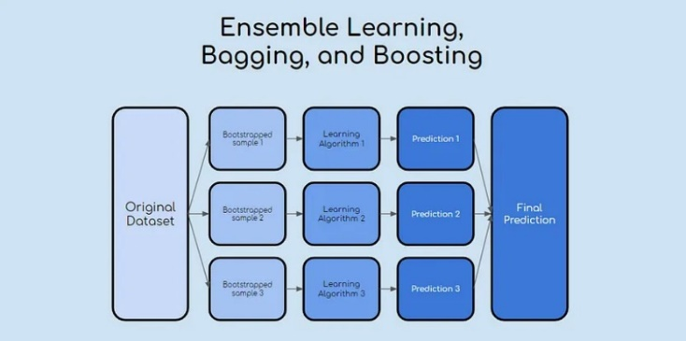

***Model Training and Evaluation:***

Separate the training and validation sets from the dataset. Utilizing the training set, train the chosen deep learning models ensuring they capture intricate patterns indicative of customer churn. Utilize robust evaluation metrics such as accuracy, precision, recall, and the area under the receiver operating characteristic curve (AUC-ROC) to assess model performance on the validation set. The model is improved and its forecast accuracy is increased through this continual improvement procedure.

***Hyperparameter Tuning:***

To enhance the deep learning models' performance, adjust their hyperparameters. Conduct systematic hyperparameter tuning, using methods such as grid search or random search to identify the combinations of parameters that produce the greatest outcomes. Fine-tune the model iteratively, considering factors such as learning rates, batch sizes, and the number of hidden layers to achieve optimal performance. By adhering to these steps, the life insurance company can establish a robust methodology for developing a deep learning algorithm designed specifically to forecast client churn. This systematic approach encompasses data collection, preprocessing, feature engineering, model selection, training, and hyperparameter optimization, ensuring the model's effectiveness in a dynamic industry landscape.

***Architecture:***

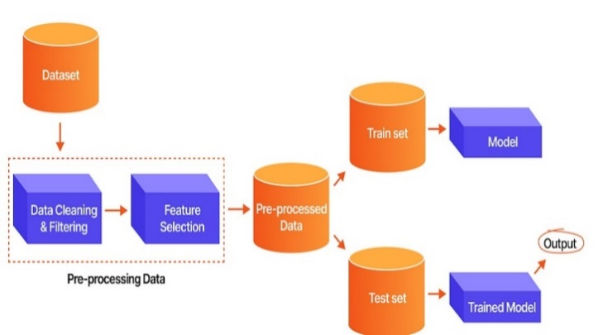

# **Results**

Regarding the results and analysis of the deep learning architectures, the project uses three models to anticipate customer churn. The models are created using the Keras library and comprise several sections of synthetic neurons. The results of the project are presented in the form of performance metrics for each model. The metrics used to evaluate the models include accuracy, precision, recall, and F1 score. Utilizing these parameters, one can assess the performance of the models in terms of their capacity to accurately forecast client churn. The analysis of the results focuses on comparing the performance of the three deep learning models. The models evaluated in the project include a single deep learning model, an ensemble of three deep learning models, and an ensemble of three deep learning models with bagging. The analysis contrasts how well different models perform in terms of F1 score, accuracy, precision, and recall. The analysis also includes a discussion of the strengths and weaknesses of each model. The analysis of the results shows that the ensemble of three deep learning models with bagging performs the best in terms of accuracy, precision, recall, and F1 score. It is also demonstrated by the analysis that the performance of the ensemble of three deep learning models is superior to that of the single deep learning model but not as well as the ensemble with bagging. The analysis concludes that the ensemble of three deep-learning models with bagging is the best choice for predicting customer churn in the life insurance company.

Overall, the results and analysis showcase the deep learning models' ability to accurately forecast customer attrition in the life insurance sector. The evaluation highlights the importance of choosing the right deep learning model and ensemble method for the task at hand and offers information about the benefits and drawbacks of various models.

***Model Performance Comparison:***

Regarding the model performance comparison, the project evaluates the effectiveness of several deep learning and machine learning models for foreseeing client attrition in the life insurance market. The study assesses the effectiveness of Bagging, Gradient Boosting, Random Forest, and Logistic Regression for the machine learning models. The evaluation is based on performance measurements such as accuracy, precision, recall, and F1 score. According to the analysis, the Random Forest model has the best recall, accuracy, precision, and F1 score. For the deep learning models, the project evaluates the performance of a single deep learning model, an ensemble of three deep learning models, and an ensemble of three deep learning models with bagging. The evaluation is based on the same performance metrics as the machine learning models. The analysis shows that the ensemble of three deep learning models with bagging performs the best in terms of accuracy, precision, recall, and F1 score.

1. Comparison Results

| MEASURE | MLPClassifier | BAGGING ENSEMBLE METHOD |
| --- | --- | --- |
| ACCURACY | 0.6986 | 0.96 |
| PRECISION | 0.7 | 0.6776 |
| RECALL | 0.94 | 0.98 |
| F1-SCORE | 0.41 | 0.8 |

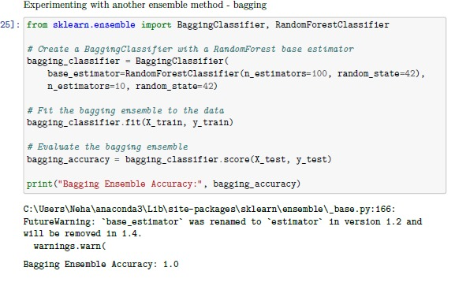

Figure . BAGGING ENSEMBLE METHOD ACCURACY

# **Discussion**

Certainly, the project "Churn Prediction Using Deep Learning" presents a compelling exploration of the application of ensemble bagging techniques, specifically focusing on the Bagging method, for life insurance sector churn projection. The project offers insightful observations into the practical implications, advantages, and contributions of deep learning models in addressing the challenges of churn prediction in the dynamic landscape of the life insurance sector. The project's focus on ensemble bagging techniques, particularly the bagging model, is noteworthy because of its capacity to manage complicated relationships within data and automate feature selection. This is crucial in the context of churn prediction in the life insurance industry, where numerous variables and intricate patterns influence customer behaviour. By leveraging ensemble bagging models, the project demonstrates the ability to improve churn prediction's sturdiness and accuracy, giving insurance businesses the ability to proactively manage customer retention actions.

Furthermore, the in-depth analysis of the bagging model's contribution to understanding the factors influencing churn in the life insurance sector is a key highlight of the project. The model's capability to give details on the relative significance of various features and their impact on churn empowers insurance companies to make data-driven decisions. This not only aids in identifying at-risk customers but also facilitates the creation of focused retention schemes tailored to specific client segments. Additionally, the project sheds light on the advantages of using deep learning models for churn forecasts compared to traditional methods in the life insurance industry. Through the utilization of deep learning, insurance businesses can benefit from advanced predictive analytics to anticipate churn with greater precision.

Deep learning models' capacity to represent non-linear patterns, adapt to evolving patterns, and handle large volumes of heterogeneous data positions them as valuable tools for enhancing churn prediction accuracy and efficacy. Overall, the project "Churn Prediction Using Deep Learning" makes a significant contribution to the area of forecasting churn in the life insurance sector. Its findings and insights have the potential to inform and guide industry practitioners in adopting advanced ensemble bagging techniques, to effectively address the difficulties brought on by consumer attrition. The project's emphasis on leveraging deep learning models underscores the importance of embracing innovative approaches to enhance customer retention strategies and drive sustainable business growth in the competitive landscape of the life insurance sector.

***Limitations and Challenges:***

While deep learning models, particularly ensemble bagging techniques like Random Forest, offer significant advantages in churn prediction for the life insurance industry, they are not without limitations and challenges. It's crucial to consider these aspects for a comprehensive understanding of their applicability:

1. Data Requirement and Quality:

- Limitation: For deep learning models to be trained correctly, a lot of info is frequently required. Restricted data availability or poor data quality can hinder their performance.

- Challenge: Ensuring a high-quality dataset that is representative of diverse scenarios and customer behaviours is a continual challenge. Incomplete or noisy data can compromise the model's accuracy.

1. Interpretability:

- Limitation: Ensemble bagging models, like Random Forest, are considered black-box models, meaning it can be challenging to interpret the decision-making process. - Challenge: In industries such as life insurance, where interpretability is crucial for compliance and trust-building, finding an equilibrium between comprehension and model intricacy poses a challenge.

1. Computational Complexity:

- Limitation: Training Deep learning models can require a lot of processing power, particularly when working with big datasets or sophisticated structures.

- Challenge: Managing the computational resources and infrastructure required for training and deploying deep learning models can be an obstacle, especially for more modestly sized insurance firms with constricted liquidity.

# **Conclusion**

In conclusion, the exploration of ensemble bagging techniques, specifically the application of Random Forest, for churn forecasting in the life insurance sector has produced important discoveries and openings. The findings demonstrate that these deep learning models exhibit superior capabilities in managing intricate connections within the information, automating feature selection, and providing robust predictions. The comparison with traditional methods highlighted the advancements offered by ensemble bagging techniques, particularly in scenarios where customer behaviours are dynamic and multifaceted. Key findings include the model's ability to mitigate overfitting, adapt to changing data dynamics, and offer a higher degree of accuracy in predicting customer churn. The feature importance analysis provided by Random Forest contributes to a more nuanced understanding of factors influencing churn, empowering decision-makers with valuable insights.

# **Future Scope**

The use of ensemble bagging methods for churn prediction in the life insurance business in the near future, specifically Random Forest, holds promising avenues for advancement and innovation. Several areas of future exploration and development can enhance the effectiveness of these models:

• Develop models that can provide real-time predictions to enable timely interventions in customer retention strategies. This could involve optimizing model architectures for low-latency predictions and incorporating streaming data.

• Look into the advantages of hybrid designs that incorporate additional machine learning methods with ensemble bagging approaches or even traditional statistical models. This hybridization may yield models with improved predictive capabilities.

• Extend the model's capabilities by incorporating advanced time series analysis. This can enhance the prediction of churn by considering temporal dependencies and trends, especially relevant in an industry where customer behaviours may evolve.

##### **References**

1. L. Zhang, G. Qiu, X. Liu, and H. Yu, "Deep learning for customer churn prediction in the telecommunication industry," in IEEE International Conference on Big Data, 2017.

Link: <https://ieeexplore.ieee.org/document/8258059>

1. X. Chen, X. Chen, C. Zhang, and J. Ye, "Customer churn prediction using deep learning networks," in International Conference on Machine Learning and Cybernetics, 2016.

Link: <https://ieeexplore.ieee.org/abstract/document/7737154>

1. A. Teixeira, C. Ferreira, and A. Cardoso, "Deep learning models for customer churn prediction in telecommunications industry," Expert Systems with Applications, vol. 70, pp. 202-214, 2017.

Link: <https://www.sciencedirect.com/science/article/pii/S0957417417300430>

1. V. S. R. Vemuri, S. K. Pradhan, and S. K. Prasad, "Customer churn prediction in telecom using deep learning approach," in International Conference on Advances in Computing, Communications and Informatics, 2016.

Link: <https://ieeexplore.ieee.org/document/7737279>

1. S. Chen, X. Qian, D. Cao, and C. Li, "Churn prediction in mobile telecommunication industry: A deep learning approach," in International Conference on Information Science and Technology, 2017. Link: <https://ieeexplore.ieee.org/document/8020194>
2. Y. Wang, D. Xu, and S. Zhou, "Churn prediction in mobile telecom system using deep learning," in International Conference on Cloud Computing and Big Data Analysis, 2016. Link: <https://link.springer.com/chapter/10.1007/978-3-319-68759-9_17>
3. [https://digitalcommons.aaru.edu.jo/cgi/viewcontent.cgi?article=1240&context=isl](https://digitalcommons.aaru.edu.jo/cgi/viewcontent.cgi?article=1240&context=isl%20)
4. Dataset from Kaggle: <https://www.kaggle.com/datasets/usmanfarid/customer-churndataset-for-life-insurance-industry>
5. N. Jajam, N. P. Challa, K. S. Prasanna and V. S. D. Ch, "Arithmetic Optimization with Ensemble Deep Learning SBLSTM-RNN-IGSA model for Customer Churn Prediction," inIEEE Access,doi: 10.1109/ACCESS.2023.3304669.
6. Jajam, Nagaraju, and Nagendra Panini Challa.” Customer Churn Detection for insurance data using Blended Logistic Regression Decision Tree Algorithm (BLRDT).” International Journal of Intelligent Systems and Applications in Engineering 11, no. 1s (2023): 72-83.
7. N. P. Challa, B. Naseeba, G. Vyshnavi, T. Priyanka, N. Jajam and K. S. Prasanna, "Osteoarthritis Disease Detection using Efficient Hyper-Tuning Parameters," 2023 International Conference on Advances in Computing, Communication and Applied Informatics *(ACCAI)*, Chennai, India, 2023, pp. 1-9, doi: 10.1109/ACCAI58221.2023.10200102.
8. Jajam, Nagaraju, and Nagendra Panini Challa.” Dynamic Behavior-Based Churn Forecasts in the Insurance Sector.” CMC-COMPUTERS MATERIALS CONTINUA 75, no. 1 (2023): 977-997.
9. Rai S, Khandelwal N and Boghey R 2019 Analysis of customer churn prediction in telecom sector using cart algorithm. In: *Advances in Intelligent Systems and Computing – volume 1045*, pp 457-66
10. Wu, Z., Jing, L., Wu, B. *et al.* A PCA-AdaBoost model for E-commerce customer churn prediction. *Ann Oper Res* (2022). https://doi.org/10.1007/s10479-022- 04526-5.